**Steps to raise exceptionss in FM**

1. Go to se37 and create FM starting with Z/Y

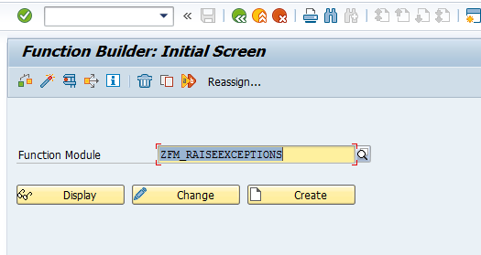

1. In the import tab, add two parameters num1 and num2

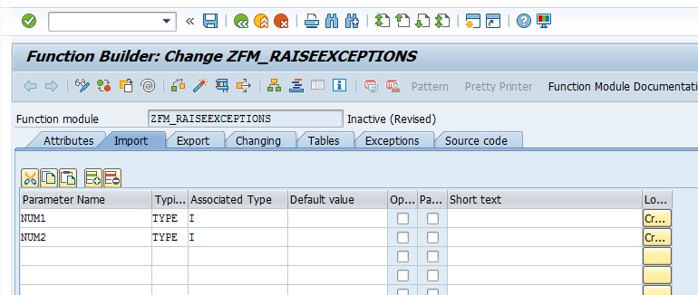

3. In the exports tab, declare the Result parameter

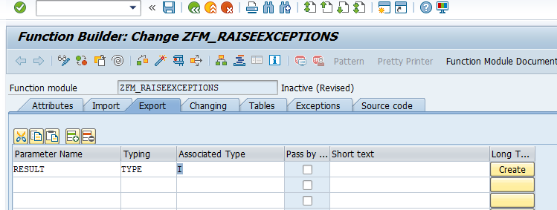

4. In the Exceptions tab, add the below

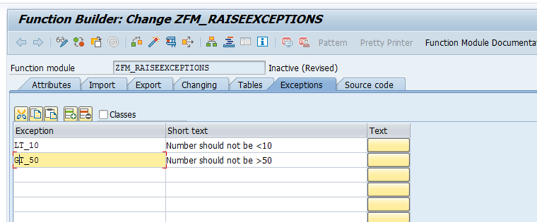

5. In the source code tab, add the below code

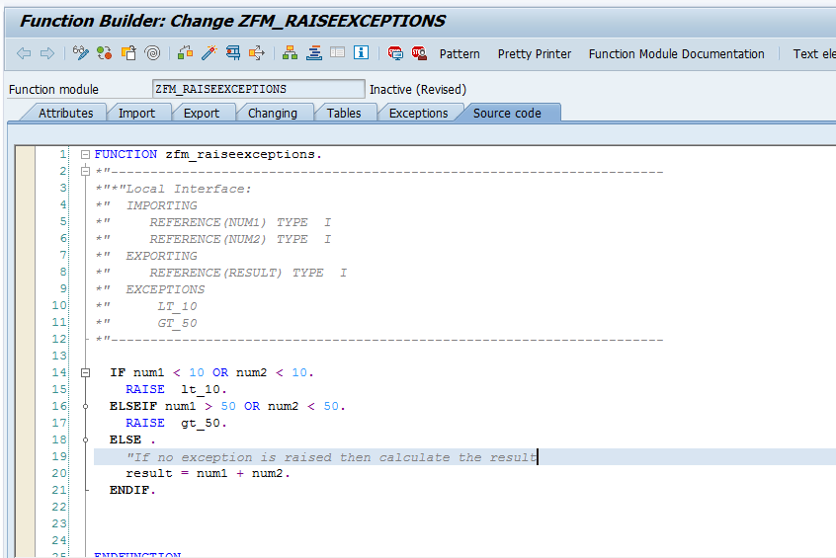

6. Save and activate the FM

7. Call the FM in the report and test the exception

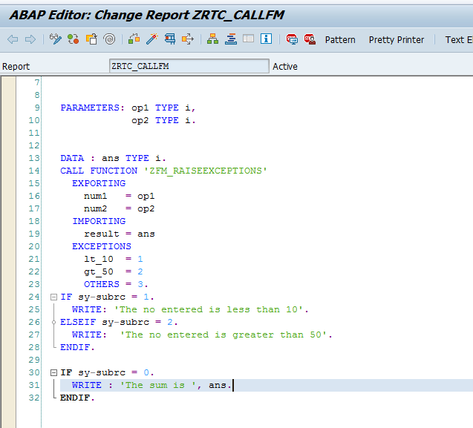

Code:

*\*&---------------------------------------------------------------------\**  
*\*& Report ZRTC_CALLFM*  
*\*&---------------------------------------------------------------------\**  
*\*&*  
*\*&---------------------------------------------------------------------\**  
REPORT zrtc_callfm.  
  
ARAMETERS: op1 TYPE i,  
            op2 TYPE i.  
  
  
DATA : ans TYPE i.  
CALL FUNCTION 'ZFM_RAISEEXCEPTIONS'  
  EXPORTING  
    num1   = op1  
    num2   = op2  
  IMPORTING  
    result = ans  
  EXCEPTIONS  
    lt_10  = 1  
    gt_50  = 2  
    OTHERS = 3.  
IF sy-subrc = 1.  
  WRITE: 'The no entered is less than 10'.  
ELSEIF sy-subrc = 2.  
  WRITE:  'The no entered is greater than 50'.  
ENDIF.  
  
IF sy-subrc = 0.  
  WRITE : 'The sum is ', ans.  
ENDIF.

7. The expected output is as below:

